**.Net Foundational Assignment**

**Project 1: Calculator**

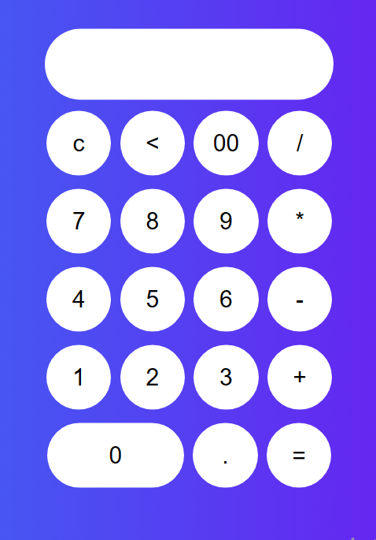**[1]**

**calculator.html**

**<html>**

**<head>**

**<title> attractive calculator</title>**

**<link rel="stylesheet" href="calculator.css">**

**</head>**

**<form name="form1" class="calci" action="calculator.html" method="POST">**

**<input type="text" name="answer" id="display">**

**<br></br>**

**<input type="button" value="c" onclick="form1.answer.value=''" class="button">**

**<input type="button" class= "button"value="<" onclick="form1.answer.value=form1.answer.value.substring(0,form1.answer.value.length*1-1)" >**

**<input type="button" class= "button"value="00" onclick="form1.answer.value+='00'">**

**<input type="button" class= "operator"value="/" onclick="form1.answer.value+='/'">**

**<br></br>**

**<input type="button" class= "button" value="7" onclick="form1.answer.value+='7'">**

**<input type="button" class= "button"value="8" onclick="form1.answer.value+='8'">**

**<input type="button" class= "button"value="9" onclick="form1.answer.value+='9'">**

**<input type="button" class= "operator"value="*" onclick="form1.answer.value+='*'">**

**<br></br>**

**<input type="button" class= "button" value="4" onclick="form1.answer.value+='4'">**

**<input type="button" class= "button"value="5" onclick="form1.answer.value+='5'">**

**<input type="button" class= "button"value="6" onclick="form1.answer.value+='6'">**

**<input type="button" class= "operator"value="-" onclick="form1.answer.value+='-'">**

**<br></br>**

**<input type="button" class= "button"value="1" onclick="form1.answer.value+='1'">**

**<input type="button" class= "button"value="2" onclick="form1.answer.value+='2'">**

**<input type="button" class= "button"value="3" onclick="form1.answer.value+='3'">**

**<input type="button" class= "operator"value="+" onclick="form1.answer.value+='+'">**

**<br></br>**

**<input type="button" class= "button" value="0" onclick="form1.answer.value+='0'" id="zero">**

**<input type="button" class= "button" value="." onclick="form1.answer.value+='.'">**

**<input type="button" class= "operator" value="=" onclick="form1.answer.value=eval(form1.answer.value)">**

**</form>**

**</html>**

**calculator.css**

**body{**

**margin: 0;**

**padding:0;**

**line-height: 0.5;**

**background:linear-gradient(to left,#7808f0,#06bdf5);**

**font-family: sans-serif;**

**}**

**.calci{**

**width: 500px;**

**padding-top: 100px;**

**padding-bottom: 100;**

**position: absolute;**

**top:50%;**

**left:70%;**

**transition:0.25px;**

**transform: translate(-50%,-50%);**

**text-align: center;**

**}**

**#zero{**

**height: 55;**

**width: 116;**

**font-size: 20;**

**font-family: sans-serif;**

**font-weight: 300;**

**}**

**#display{**

**border:none;**

**background: white;**

**border-radius: 30px;**

**width: 245;**

**font-size: 20;**

**font-family: sans-serif;**

**font-weight: 300;**

**height: 60;**

**margin: auto;**

**border:2px solid white(5, 218, 255, 0.726);**

**color: black**

**}**

**.button{**

**width: 55;**

**height: 55;**

**padding-top: -1;**

**font-size: 20;**

**border: none;**

**background: white;**

**font-family: sans-serif;**

**font-weight: 300;**

**border:0;**

**border-radius: 30px;**

**margin: 1.5;**

**transition:0.25px;**

**}**

**h1{**

**margin-top: 300px;**

**margin-left: 100px;**

**font-family: sans-serif;**

**font-size:50;**

**text-decoration: underline;**

**color: white;**

**text-transform: uppercase;**

**font-weight: 700;}**

**h2{**

**color: white;**

**margin-top: -1px;**

**font-family: sans-serif;**

**margin-left: 438px;**

**}**

**.operator{**

**width: 55;**

**height: 55;**

**padding-top: -1;**

**font-size: 20;**

**text-align: center;**

**color: black;**

**border: none;**

**background: white;**

**font-family: sans-serif;**

**font-weight: 500;**

**border:0;**

**border-radius: 30px;**

**margin: 1.5;**

**transition:0.25px;**

**cursor:pointer;**

**}**

**.operator:hover{**

**background: #00d9ff;**

**}**

**Project 2: ECommerce Management**

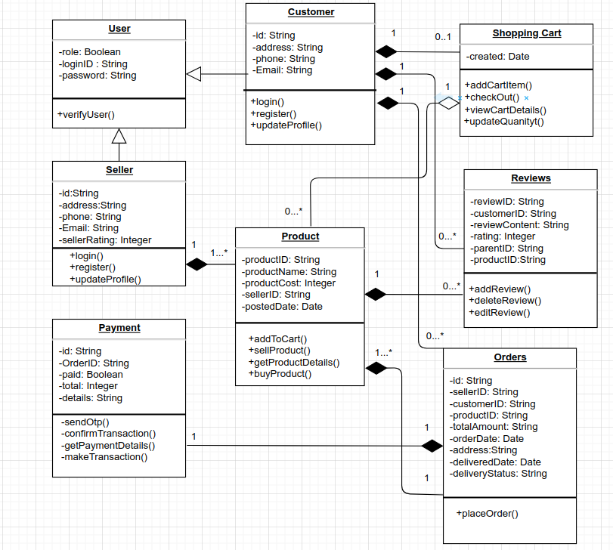

**Customer.java**

**package Ecommerce;**

**import java.util.*;**

**public class Customer extends User {**

**public Customer() {**

**}**

**private String id;**

**private String address;**

**private String phone;**

**private String email;**

**public void login() {**

**System.out.printl("Loggedin Successfully");**

**}**

**public void register() {**

**System.out.printl("Registered Successfully");**

**}**

**public void updateProfile() {**

**System.out.printl("Profile Updated");**

**}**

**}**

**Orders.java**

**package Ecommerce;**

**import java.util.*;**

**public class Orders {**

**public Orders() {**

**}**

**private String id;**

**private String customer;**

**private String productID;**

**private String totalAmount;**

**private Date orderDate;**

**private String address;**

**private Date deliveredDate;**

**private String deliveryStatus;**

**public void placeOrder() {**

**System.out.printl("Ordered Placed Successfully");**

**}**

**}**

**Payment.java**

**package Ecommerce;**

**import java.util.*;**

**public class Payment {**

**/\*\***

**\* Default constructor**

**\*/**

**public Payment() {**

**}**

**private String id;**

**private String orderID;**

**private Boolean paid;**

**private String details;**

**private void sendOtp() {**

**System.out.printl("OTP Sent");**

**}**

**private void confirmTransaction() {**

**System.out.printl("Confirm the Transaction");**

**}**

**private void getPaymentDetails() {**

**System.out.printl("Payment Details");**

**}**

**private void makeTransaction() {**

**System.out.printl("Transaction Completed");**

**}**

**}**

**Product.java**

**package Ecommerce;**

**import java.util.*;**

**public class Product {**

**/\*\***

**\* Default constructor**

**\*/**

**public Product() {**

**}**

**private String productID;**

**private String productName;**

**private Integer productCost;**

**private String sellerID;**

**private Date postedDate;**

**public void addToCart() {**

**System.out.printl("Item Added");**

**}**

**public void sellProduct() {**

**System.out.printl("Item Sold");**

**}**

**public void getProductDetails() {**

**System.out.printl("Item Details");**

**}**

**public void buyProduct() {**

**System.out.printl("Item bought");**

**}**

**}**

**Reviews.java**

**package Ecommerce;**

**import java.util.*;**

**public class Reviews {**

**/\*\***

**\* Default constructor**

**\*/**

**public Reviews() {**

**}**

**private String reviewID;**

**private String customerID;**

**private String reviewContent;**

**private String rating;**

**private String parentID;**

**private String productID;**

**public void addReview() {**

**System.out.printl("Review Added");**

**}**

**public void deleteReview() {**

**System.out.printl("Review Deleted");**

**}**

**public void editReview() {**

**System.out.printl("Review Edited");**

**}**

**}**

**Seller.java**

**package Ecommerce;**

**import java.util.*;**

**public class Seller extends User {**

**/\*\***

**\* Default constructor**

**\*/**

**public Seller() {**

**}**

**private String id;**

**private String address;**

**private String phone;**

**private String email;**

**private Integer sellerRating;**

**public void login() {**

**System.out.printl("Loggedin Successfully");**

**}**

**public void register() {**

**System.out.printl("Registered Successfully");**

**}**

**public void updateProfile() {**

**System.out.printl("Profile Updated");**

**}**

**}**

**Shopping_Cart.java**

**package Ecommerce;**

**import java.util.*;**

**public class Shopping_Cart {**

**/\*\***

**\* Default constructor**

**\*/**

**public Shopping_Cart() {**

**}**

**private Date created;**

**public void addCartItem() {**

**System.out.printl("Item Added");**

**}**

**public void checkOut() {**

**System.out.printl("Item CheckedOut");**

**}**

**public void viewCartDetails() {**

**System.out.printl("These are Items in cart");**

**}**

**public void updateQuantity() {**

**System.out.printl("Quantity Updated");**

**}**

**}**

**User.java**

**package Ecommerce;**

**import java.util.*;**

**public class User {**

**/\*\***

**\* Default constructor**

**\*/**

**public User() {**

**}**

**private Boolean role;**

**private String loginID;**

**private String password;**

**public void verifyUser() {**

**System.out.printl("User Verified!");**

**}**

**}**

1.